Lab Report – Nutrient Analysis
Complete the questions in the following sections.

Background [15 pts]
Each student selected five samples from the Hundred Acre Cove dataset to study in more detail. Find your selected samples at http://gdgts.github.io/samples.html and list them in the table below.
# | Sample ID
1
2
3
4
5

[5 pts] The samples you selected were analyzed for NH_{4,} NO₃, PO₄, and SiO₂. List the molecular weight, charge, and oxidation state of each species in the table below (e.g. +1, -3, +4, etc.).

Compound | Molecular Weight | Charge | Oxidation State
NH₄
NO₃
PO₄
SiO₂

# | Sample ID | Type | Lat. (°N) | Long. (°E)
1
2
3
4
5

[10 pts] Anthropogenic processes can have a significant impact on these cycles. Use the map at http://gdgts.github.io/map.html to find anthropogenic sources that may influence the nutrient concentration of your selected samples (e.g. agriculture, traffic, septic tanks, urban communities, etc.). Find one source per sample.

Calibration [40 pts]
Samples were analyzed using a SmartChem200 Discrete Spectrometer (i.e. a research grade analytical instrument priced around ~$75,000-$100,000). Samples undergo a reaction that specifically targets the nutrient being analyzed (e.g. NH₄, NO₃, PO₄, Si), the product of which absorbs a certain wavelength of light proportional to the quantity of product in the sample (observable at parts per billion concentration).
In order to determine the nutrient concentration in your samples, we need to establish an equation to convert the raw instrument data (i.e. absorbance) to concentration units (i.e. ppb). We can do this using a calibration curve, built using data obtained from standards of known concentrations. Use the data provided to construct a calibration curve for NH₄, NO₃, PO₄, Si. Here’s a walkthrough for doing this in Excel or Google Docs:

- Open the file “HundredAcreCove2014_Nutrients.xls”.
- We need to establish a linear regression equation for our data (y = mx + b) in order to convert absorbance to concentration. To calculate the slope (m), find an empty cell and paste the following:
=slope(B2:B17, C2:C17)
where B2:B17 are the concentration values of the calibration standards and C2:C17 are the absorbance values of the calibration standards.
- Find an empty cell next to your calculated slope and paste the following:
=intercept(B2:B17, C2:C17)
- Calculate the correlation coefficient between concentration and absorbance by pasting the following into an empty cell:
=correl(B2:B17, C2:C17)
- Alternatively, select the concentration and absorbance values with your mouse, go to the ‘insert’ tab near the top of the screen, and select ‘scatter’ (Excel) or ‘chart → scatter’ (Google Docs).
- Right click on any data point in your scatter plot and select ‘add trendline’ (Excel) or ‘advanced edit → scroll down to ‘series’ (Google Docs).
- Select ‘linear’ trendline type. Select options to show ‘equation’ and ‘R²’.

[10 pts] Complete the following table for each nutrient calibration set.
Calibration Model | Slope (m) | Intercept (b) | R²
NH₄
NO₃
PO₄
SiO₂

[10 pts] Plot the concentration and absorbance values of the calibration data for each of the four species examined.
Before applying the calibration to your samples, evaluate the accuracy of your calibration model by examining the residual errors.
- Use your calibration equation to determine the predicted concentration of your calibration standards.
- Calculate the residuals by subtracting the predicted concentration from the actual concentration.
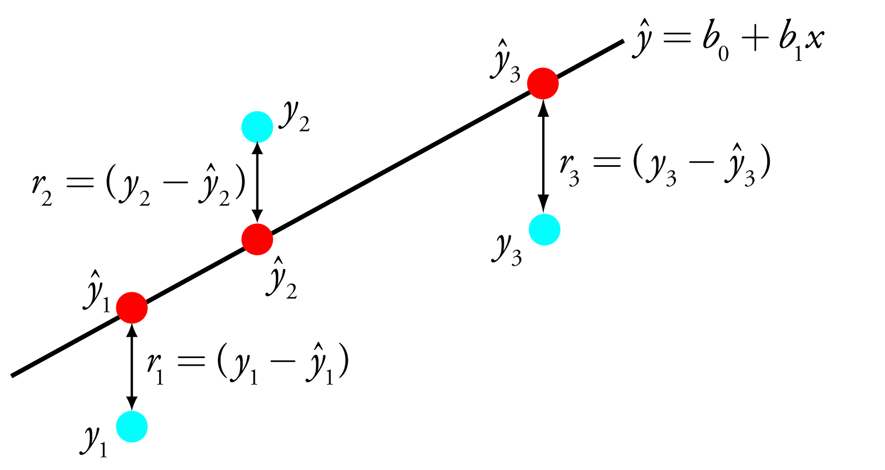
- Here’s an example:
Absorbance | Concentration (ppb) |  | Residuals
Absorbance | Actual | Predicted | Actual - Predicted
-0.019 | 0.000 | 8.399 | -8.399
0.001 | 48.850 | 69.692 | -20.842
0.019 | 97.700 | 122.315 | -24.615
0.034 | 195.400 | 167.762 | 27.638
0.069 | 293.100 | 273.306 | 19.794
0.101 | 390.800 | 367.190 | 23.610
0.173 | 586.200 | 584.258 | 1.942

[10 pts] Plot actual concentration (x) vs. residuals (y) for each calibration model (NH₄, NO₃, PO₄, SiO₂).
Finally calculate the root-mean-square deviation of your calibration model (RMSD) to assess the accuracy of your model.
- In a new column, square the residual values from each row.
- Now calculate the sum of the residuals squared and divide by the number of calibration samples.
- Take the square root of this value to obtain the RMSD value.
Absorbance | Concentration (ppb) |  | Residuals | Residuals²
Absorbance | Actual | Predicted | Actual - Predicted | (Actual – Predicted)²
-0.019 | 0.000 | 8.399 | -8.399 | 70.543
0.001 | 48.850 | 69.692 | -20.842 | 434.388
0.019 | 97.700 | 122.315 | -24.615 | 605.898
0.034 | 195.400 | 167.762 | 27.638 | 763.859
0.069 | 293.100 | 273.306 | 19.794 | 391.802
0.101 | 390.800 | 367.190 | 23.610 | 557.432
0.173 | 586.200 | 584.258 | 1.942 | 3.771
 |  |  | Sum of Residuals² | 2827.695
 |  |  | Divide by # Samples | 403.956
 |  |  | Take Square Root | 20.098 (RMSD)
[10 pts] Calculate the RMSD for each calibration model and report the values below.

Calibration Model | RMSD (ppb)
NH₄
NO₃
PO₄
SiO₂

Samples [10 pts]
[10 pts] Apply the calibration curve calculated in the previous section to your samples. Determine the nutrient concentration (ppb) for each of your five samples from the absorbance data and record the values in the table below.

# | Sample ID | NH₄ (ppb) | NH₃ (ppb) | PO₄ (ppb) | SiO₂ (ppb)
1
2
3
4
5

Analysis [35 pts]
The environment encodes information about itself through the chemistry taking place within it. For example, information about algal populations in the aquatic environment is encoded in the total nitrogen, phosphorous and silica concentrations (http://lakewatch.ifas.ufl.edu/circpdffolder/nutrpt2.pdf). In order to extract this information from your samples, we need perform the following steps:

[10 pts] Convert units from molecular concentration (e.g. NH₄, NO₃, PO₄, SiO₂) to elemental concentration (e.g. N in NH₄, N in NO₃, P in PO₄, Si in SiO₂). (http://www.smart-fertilizer.com/conversion-tables)

# | Sample ID | N-NH₄ (ppb) | N-NO₃ (ppb) | P-PO₄ (ppb) | Si-SiO₂ (ppb)
1
2
3
4
5

Add the N-NH₄ and N-NO₃ to give an estimate of total nitrogen.

# | Sample ID | Total N (ppb)
1
2
3
4
5

Sum the total concentration of all elements in each sample. The total of all elements is equal to: Total N (N-NH₄, N-NO₃) + Total P (P-PO₄) + Total Si (Si-SiO₂).

# | Sample ID | Total N, P, Si
1
2
3
4
5

[5 pts] Now calculate the relative abundance of each element by dividing the total concentration of each element by the total concentration of all elements. For example, %N = Total N / Total All.

# | Sample ID | %N | %P | %Si
1
2
3
4
5

[10 pts] Use these values to create a stacked bar chart. In Excel, select the values calculated above, then select the ‘insert’ tab, find the bar chart option, and select ‘stacked bar’.

[10 pts] Compare the relative distribution of nutrients at each sample location. In the ‘Algal/Plants’ column, use the map to determine if your sample location seems favorable or unfavorable for algal or plant growth. Fill out the table below and comment on any trends you see.

# | Sample ID | Algal/Plants | %N / %P | %N / %Si | %P / % Si
1
2
3
4
5

Comments:

